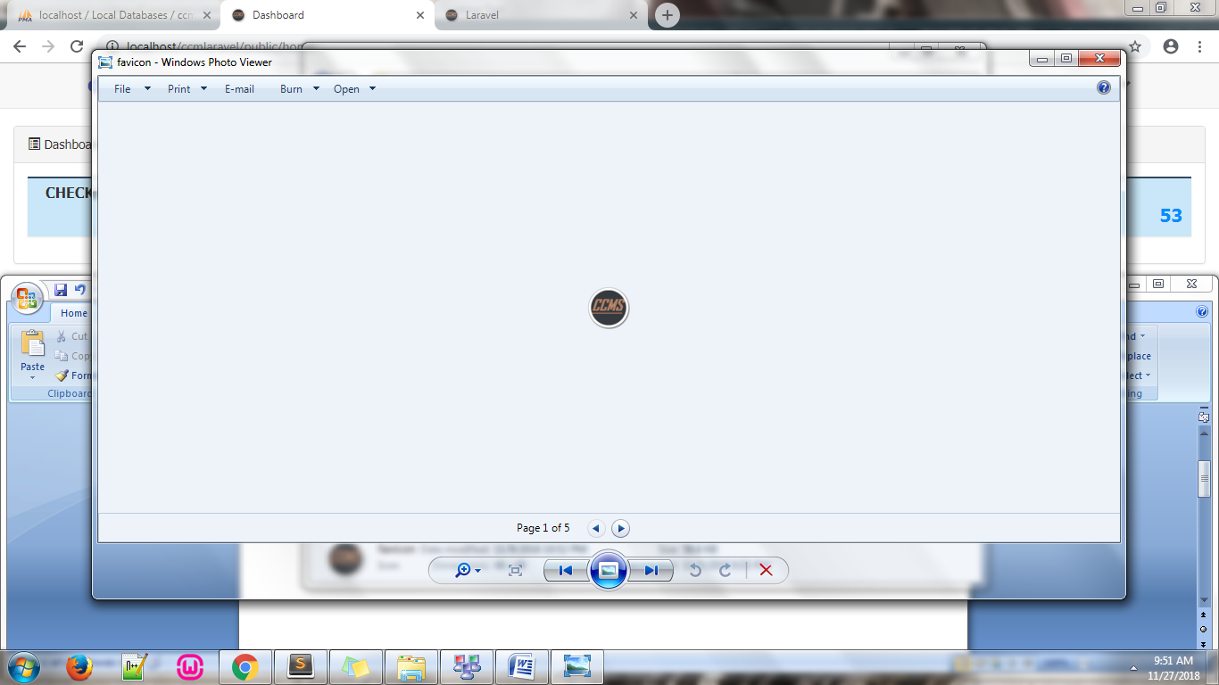**Check Clearing &**

**Monitoring**

**System**

**Modifications and Changes**



* Added an icon to the system.
* 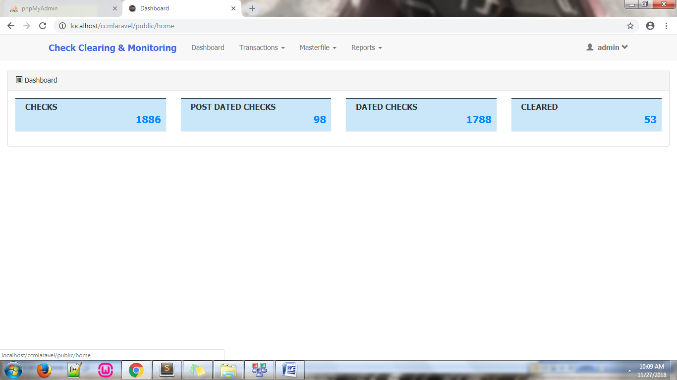Added dashboard link to the Check Clearing & Monitoring link in the navigation header which will redirect to the dashboard page.
* **Dashboard**

– added queries that will count and display the number of “CHECKS”, “POST DATED CHECKS”, “DATED CHECKS”, and “CLEARED” checks.

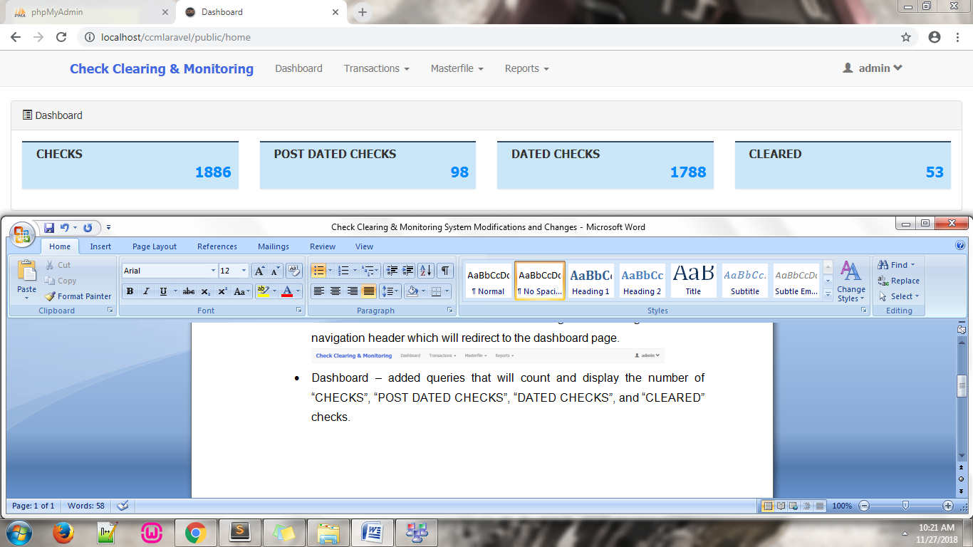– File modified: app/Http/Controllers/**HomeController.php** in ***function index()*** line **25**

* **Transactions – Check Receiving (Manual Entry and Textfile Upload)**

– modified Date Received read-only input field

from 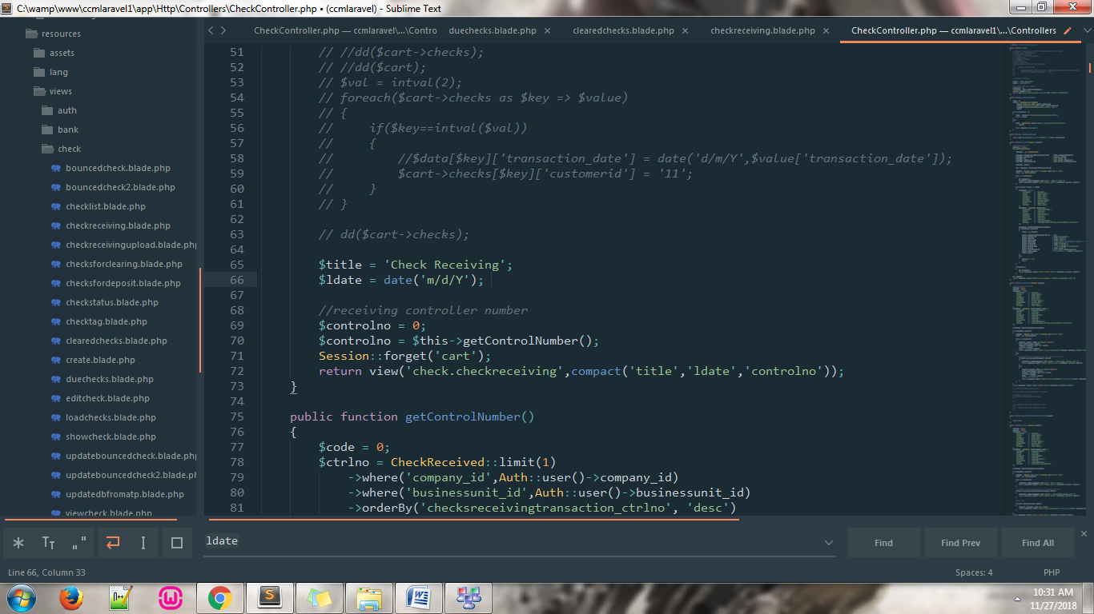 to 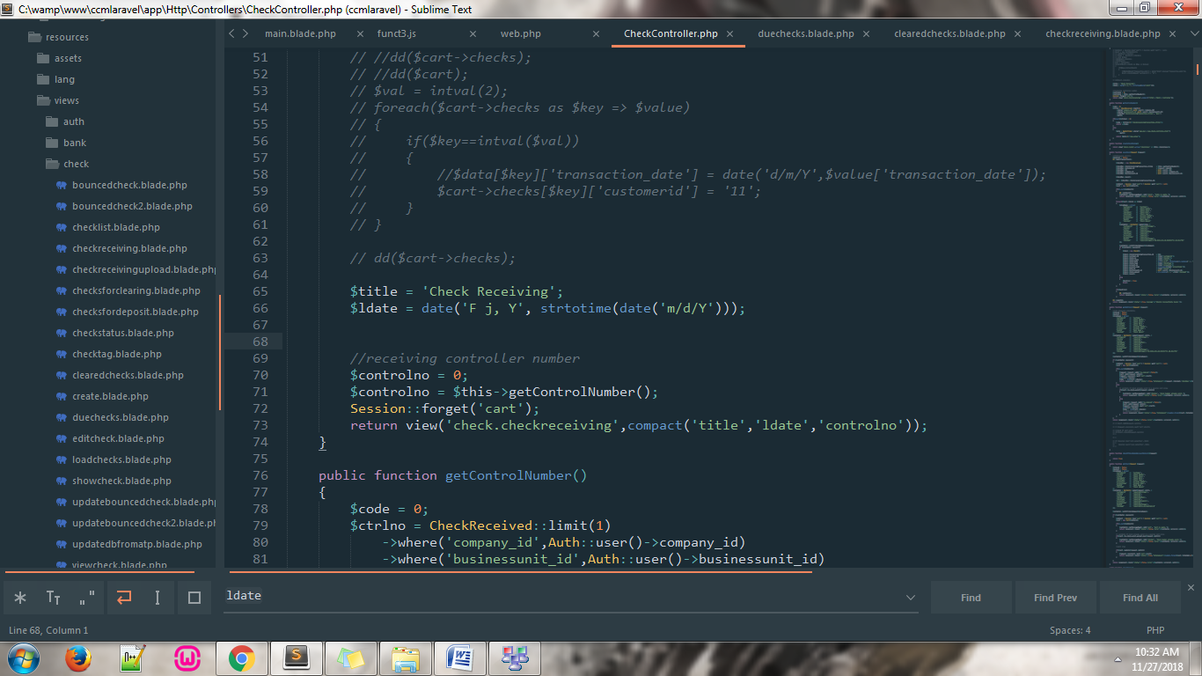

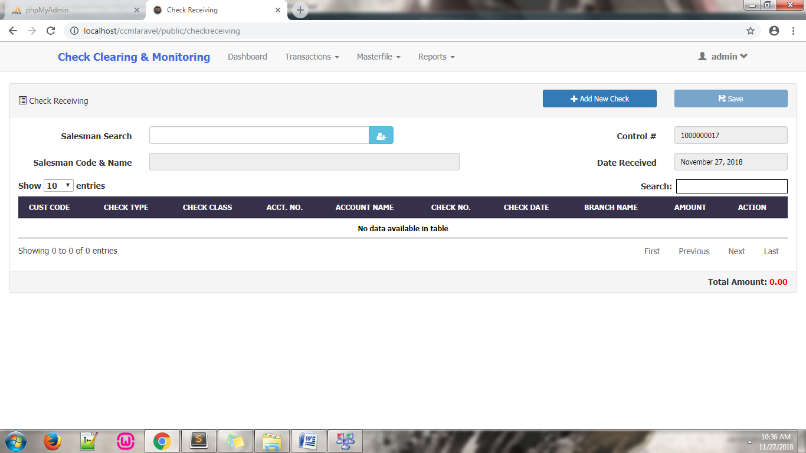Changes: from 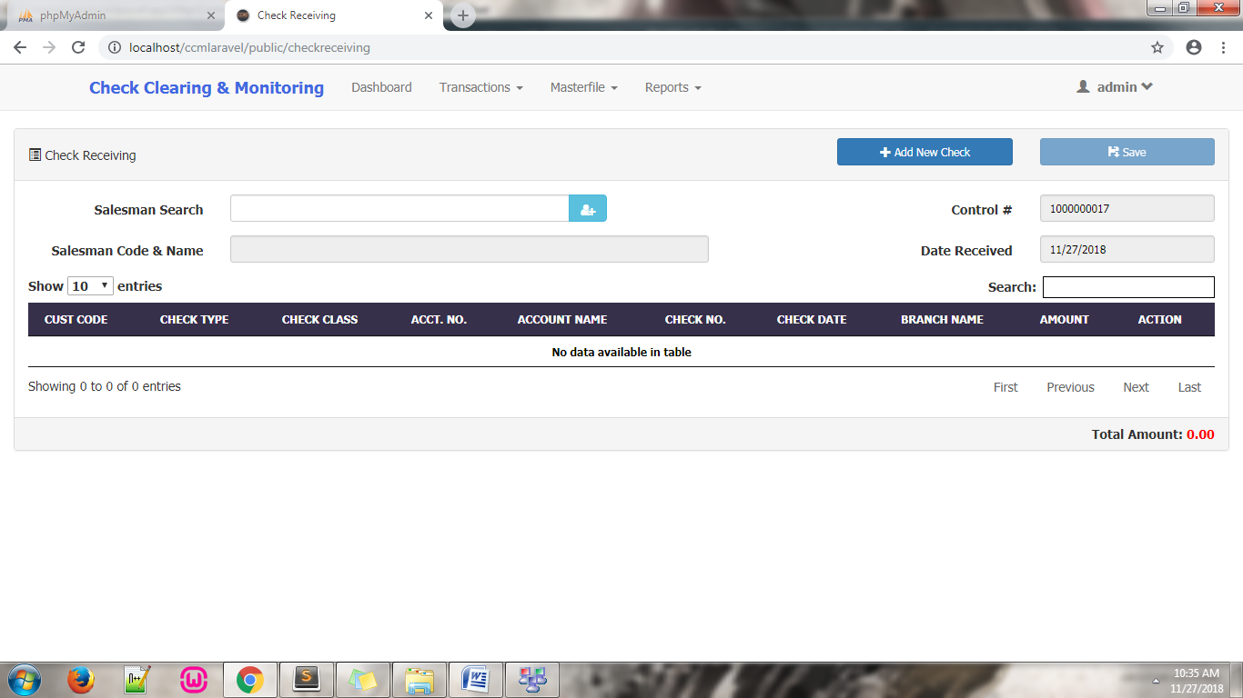 to

– Files modified:

app/Http/Controllers/**CheckController.php** in ***function index()*** line **66**

app/Http/Controllers/**CheckController.php** in ***function receivingUpload()*** line **470**

* 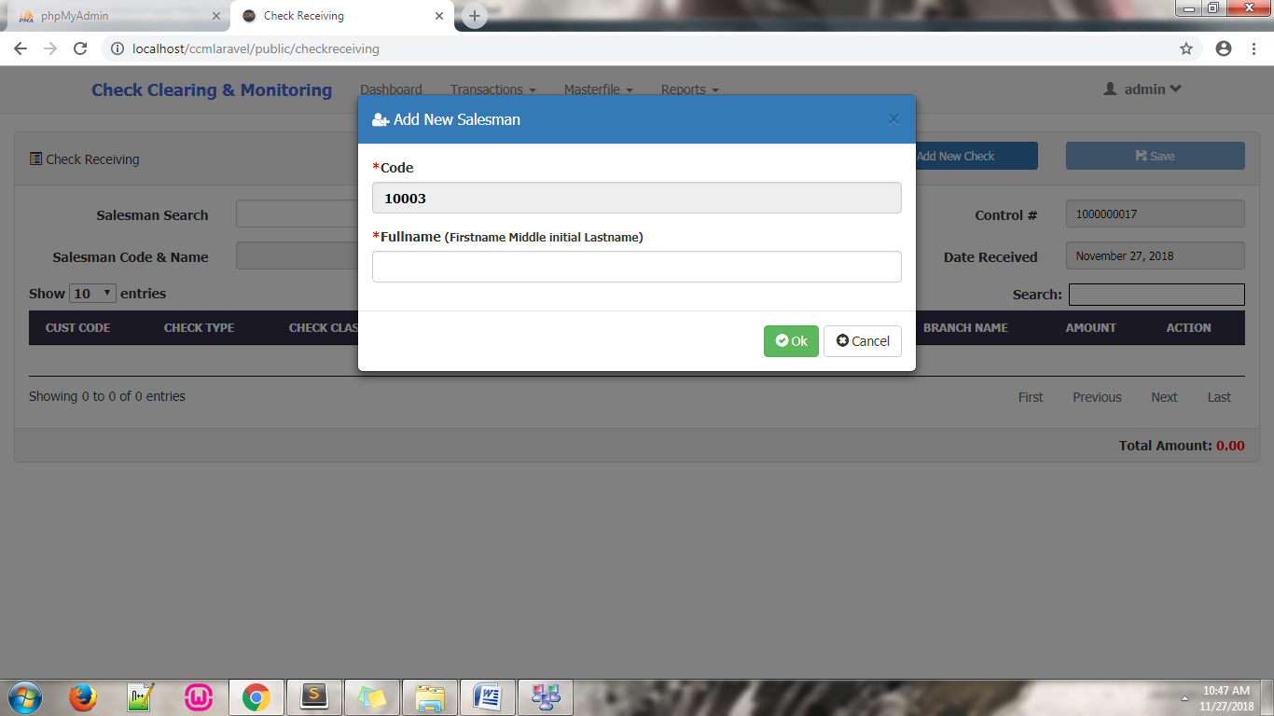Add New Salesman and Add New Customer’s Fullname input field label’s modified from

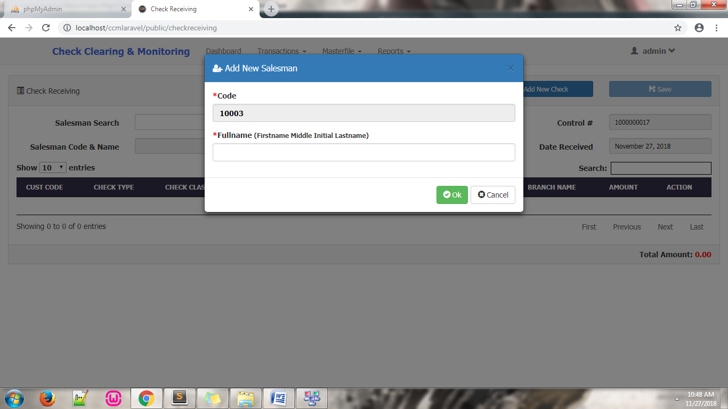 To

– Files modified:

resources/views/salesman/**addnewsalesman.blade.php** line **12**

resources/views/customer/**addnewcustomer.blade.php** line **10**

* **Transactions – Check Receiving (Manual Entry)**

– SHOW action in the Add New Check list modified

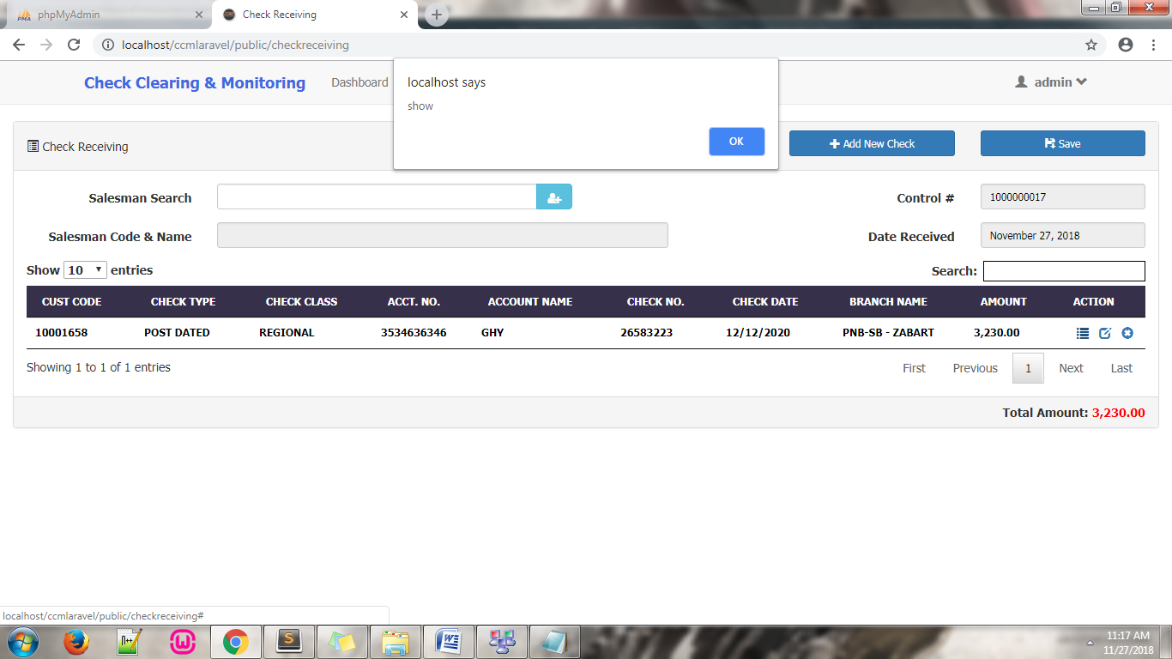from:

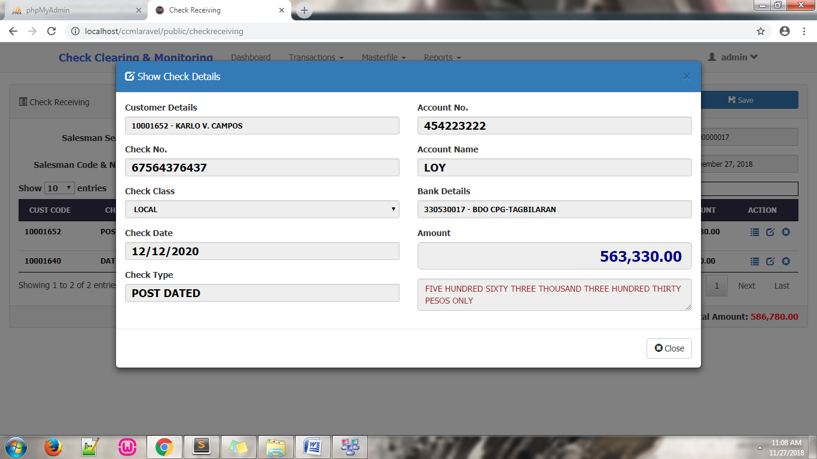

to:

*Added a view dialog box instead of showing alert notification.

– File modified:

public/js/**funct5.js** line **2403**

* **Masterfile – User**

– modified the user list; STATUS column is now capitalized, CREATED column dates has been modified, and CHANGE PASSWORD ACTION icon has been changed.

Modified from:

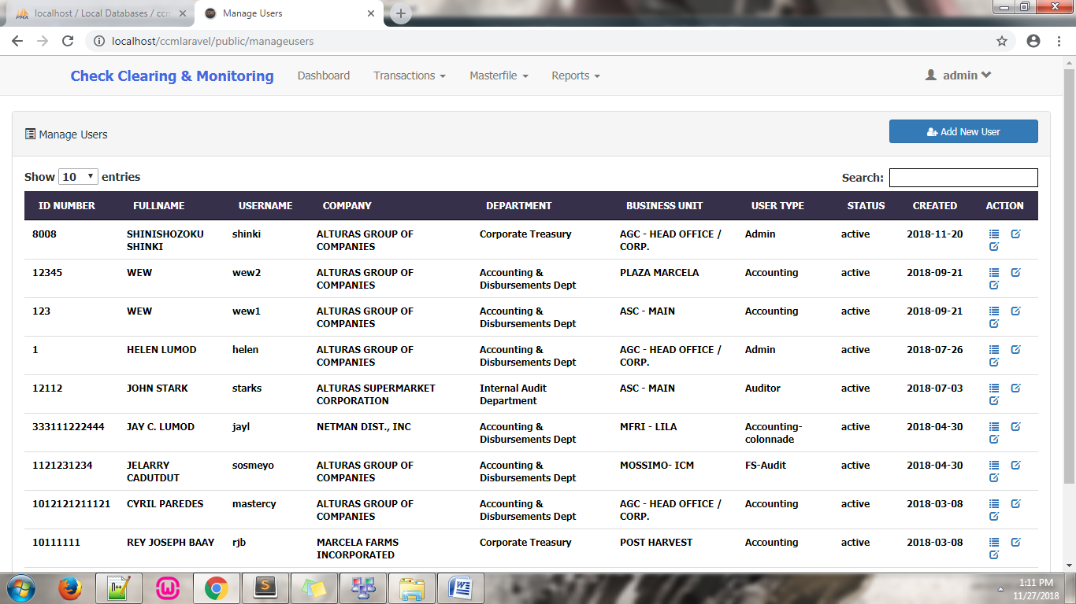

To:

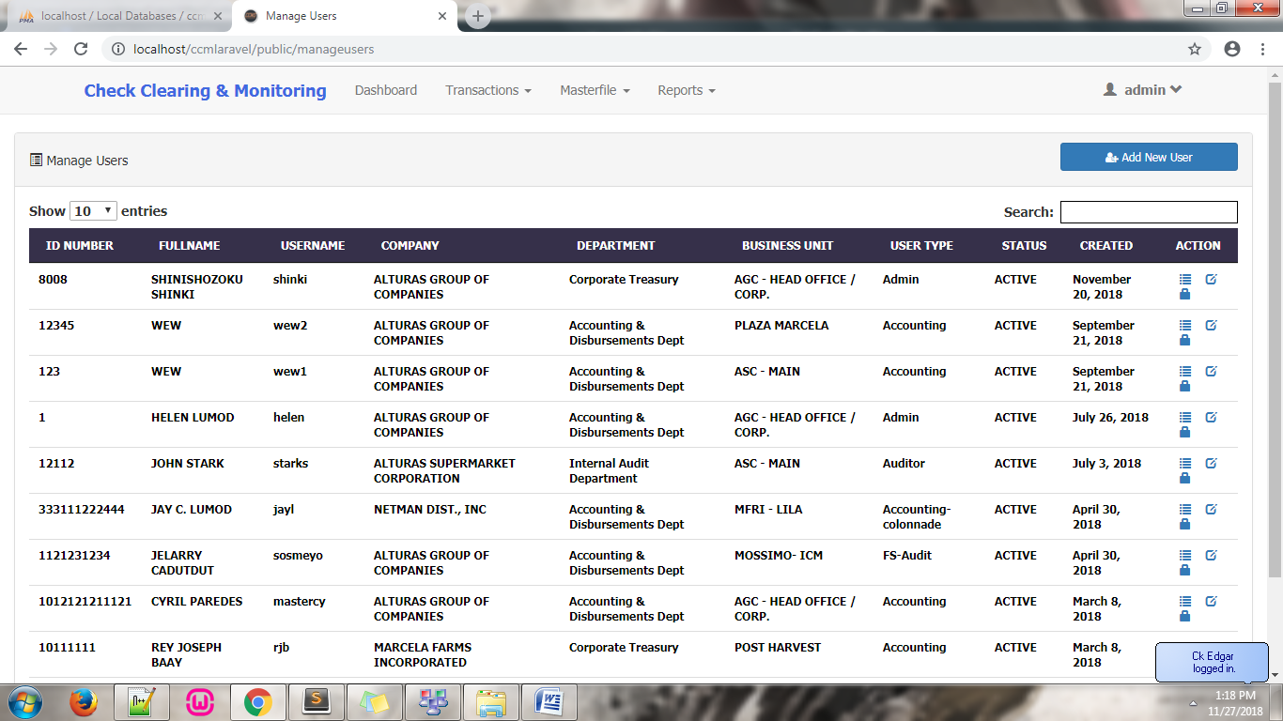

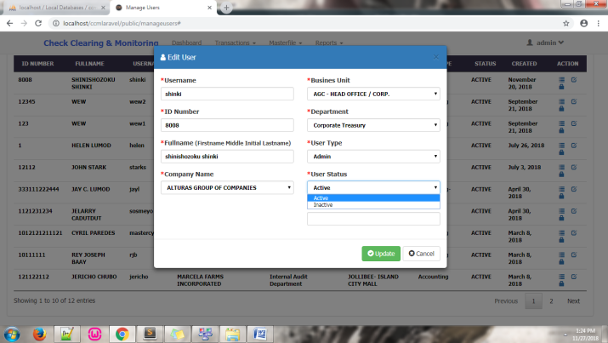– added functionality for viewing in the ACTION column, added User Status dropdown selection field in the EDIT ACTION, fixed change password unable to save new password.

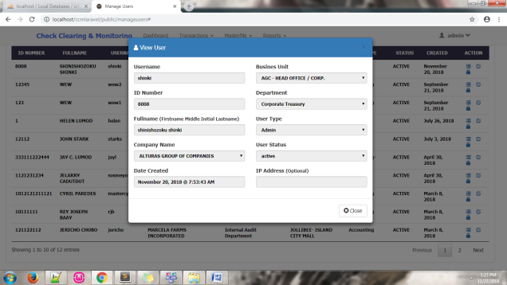

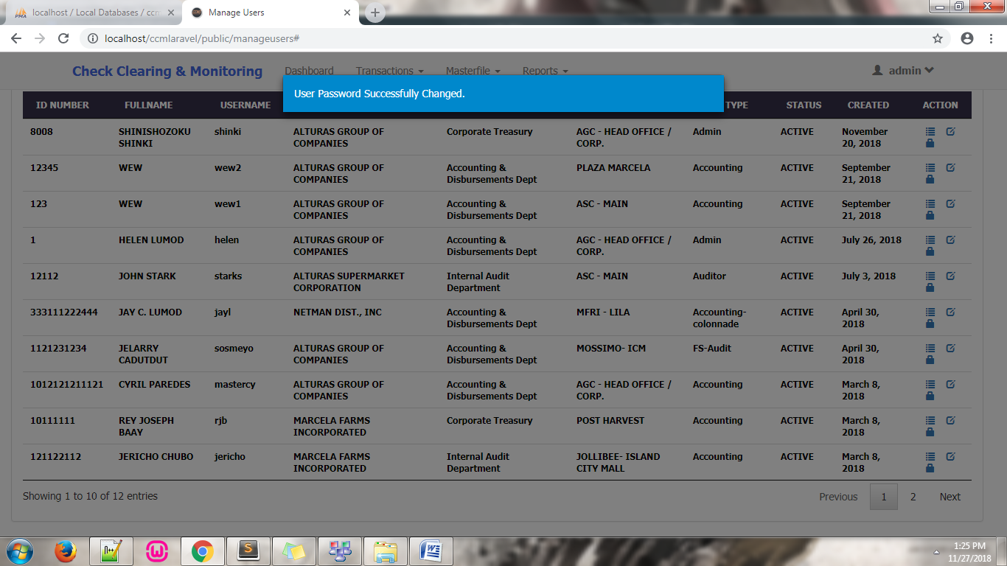

– Files modified:

* Status Capitalized: app/Http/Controllers/**UserController.php** in ***function allUsers()*** line **150**
* Date modification: app/Http/Controllers/**UserController.php** in ***function allUsers()*** line **151**
* Icon changes: app/Http/Controllers/**UserController.php** in ***function allUsers()*** line **155**

Viewing functionality files modified:

* Js: public/js/**funct5.php** line **826**
* Routes: routes/**web.php** line **30**
* Controllers: app/Http/Controllers/**UserController.php** in ***function viewuserdialog($id)*** line **170**
* View: resources/views/user/**viewuser.blade.php**

User Status dropdown selection field files modified:

* Js: public/js/**funct5.php** line **693**
* Routes: routes/**web.php** line **32**
* Controllers: app/Http/Controllers/**UserController.php** in ***function edituserdialog ($id)*** line **185**
* View: resources/views/user/**edituser.blade.php** line **56**

CHANGE PASSWORD fix files modified:

* Controllers: app/Http/Controllers/**UserController.php** in ***function changepassword(Request $request)*** line **240**
* **Masterfile – Salesman**

– modified the salesman list; CREATED column dates has been modified, and CHANGE PASSWORD ACTION has been removed.

Modified from:

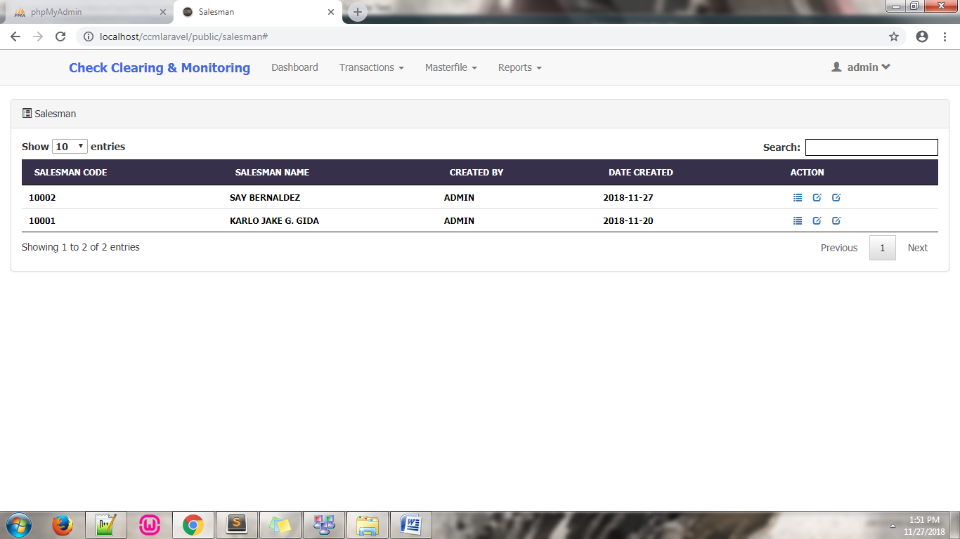

To:

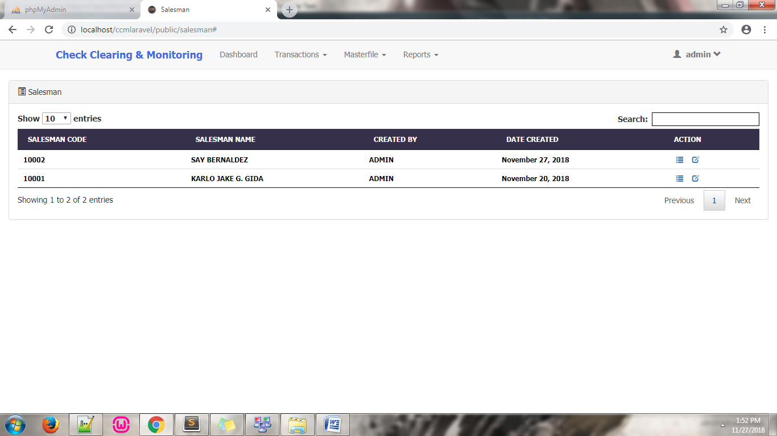

– added functionality for viewing and editing in the ACTION column.

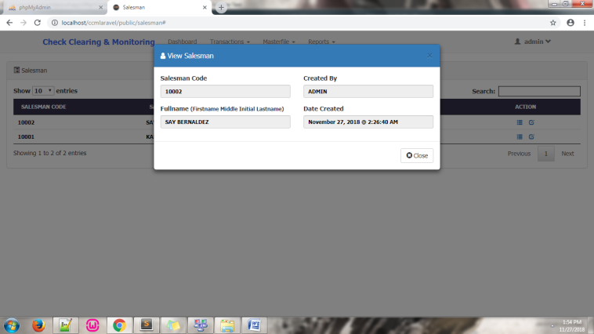

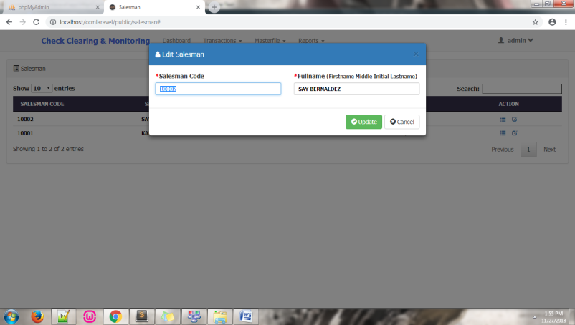

– Files modified:

* Date modification: app/Http/Controllers/**SalesmanController.php** in ***function getAllSalesman ()*** line **199**

Viewing functionality files modified:

* Js: public/js/**funct5.php** line**1064**
* Routes: routes/**web.php** line **52**
* Controllers: app/Http/Controllers/**SalesmanController.php** in ***function viewsalesmandialog($id)*** line **253**
* View: resources/views/salesman/**viewsalesman.blade.php**

Editing functionality files modified:

* Js: public/js/**funct5.php** line **1120**
* Routes: routes/**web.php** line **54**
* Controllers: app/Http/Controllers/ **SalesmanController.php** in ***function editsalesmandialog($id)*** line **261**
* View: resources/views/salesman/**editsalesman.blade.php**
* **Masterfile – Customer**

– modified the customer list; CREATED column dates has been modified, and CHANGE PASSWORD ACTION has been removed.

Modified from:

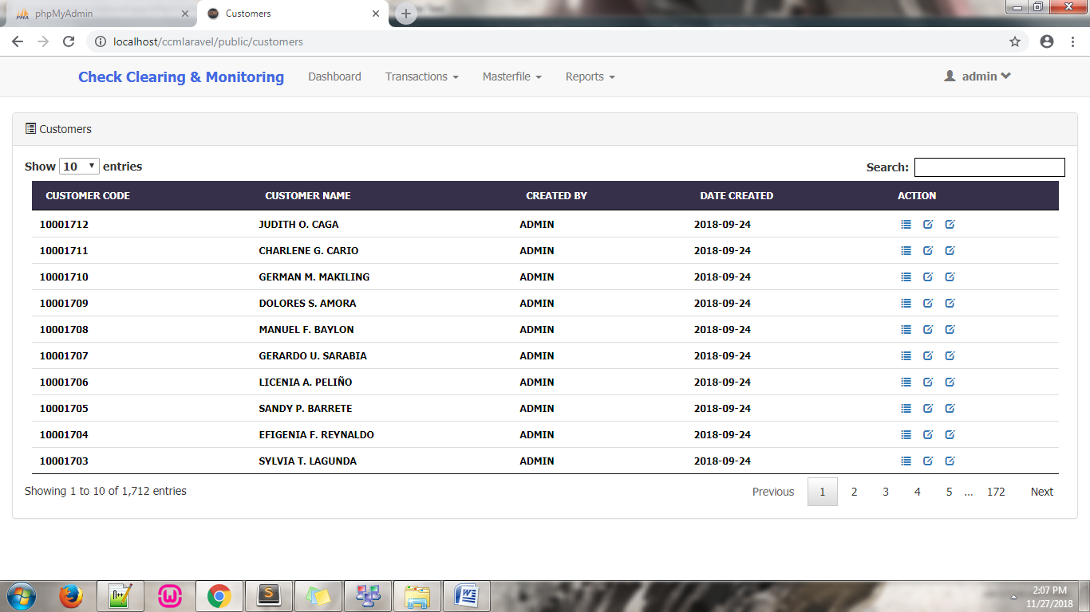

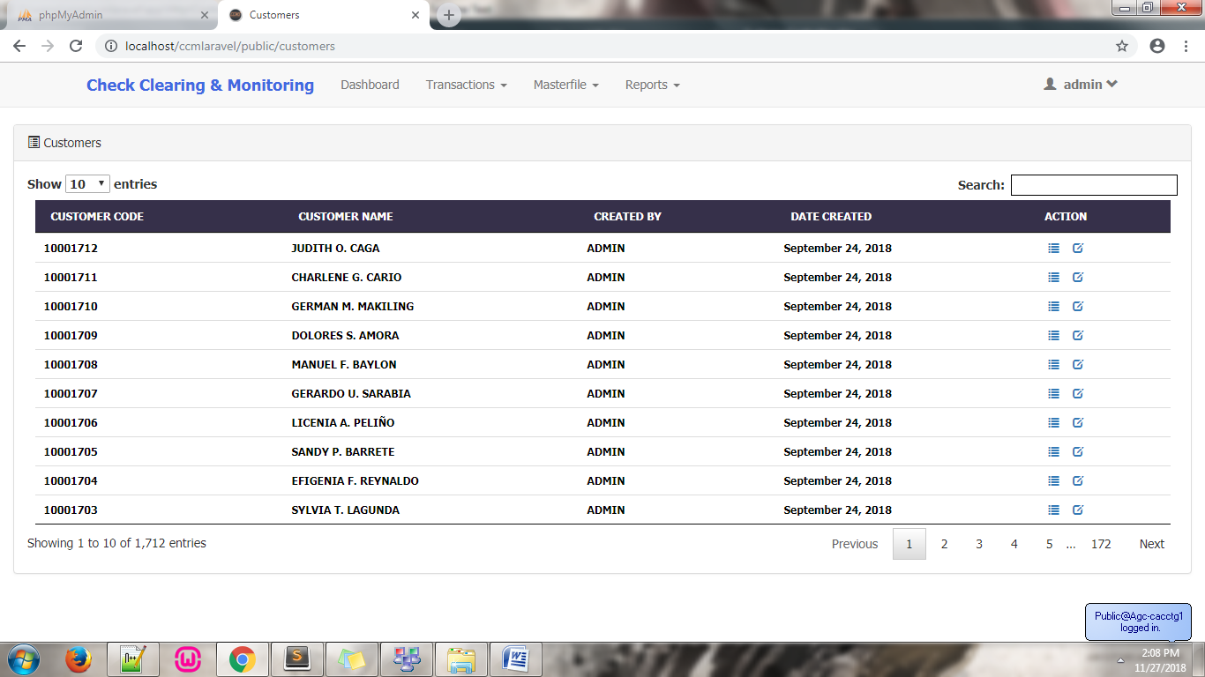To:

– added functionality for viewing and editing in the ACTION column.

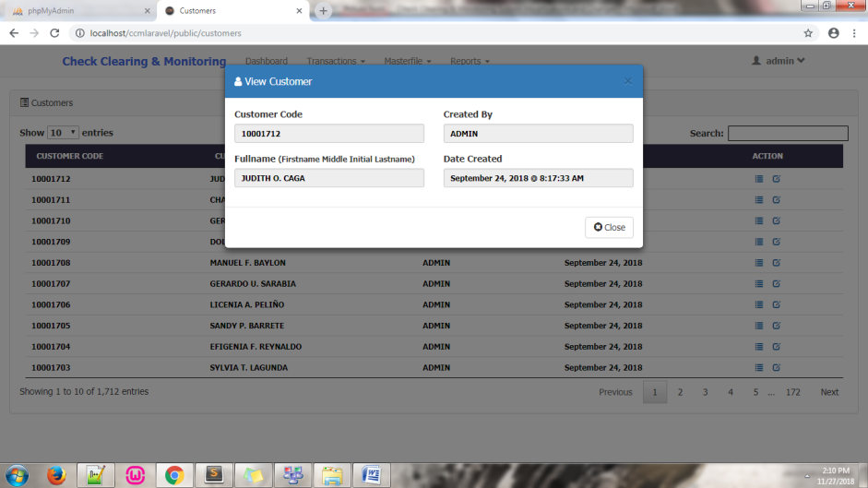

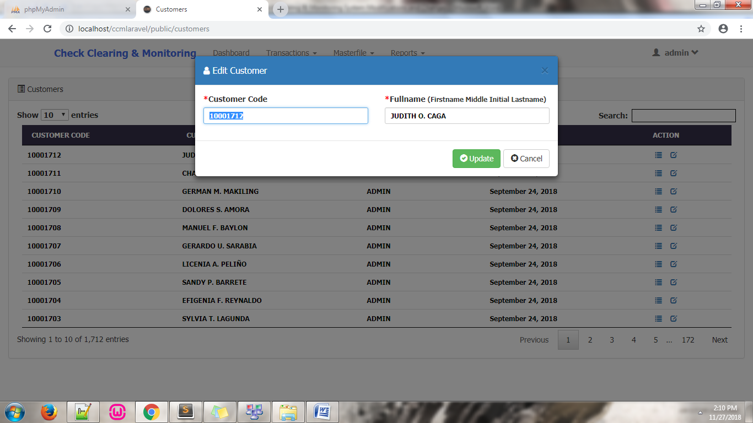

– Files modified:

* Date modification: app/Http/Controllers/**CustomerController.php** in ***function getAllCustomers ()*** line **163**

Viewing functionality files modified:

* Js: public/js/**funct5.php** line**1253**
* Routes: routes/**web.php** line **72**
* Controllers: app/Http/Controllers/**CustomerController.php** in ***function viewcustomerdialog($id)*** line **181**
* View: resources/views/customer/**viewcustomer.blade.php**

Editing functionality files modified:

* Js: public/js/**funct5.php** line **1309**
* Routes: routes/**web.php** line **74**
* Controllers: app/Http/Controllers/**CustomerController.php** in ***function editcustomerdialog($id)*** line **189**
* View: resources/views/customer/**editcustomer.blade.php**
* **Masterfile – Banks**

– modified the bank list; CREATED column dates has been modified, and CHANGE PASSWORD ACTION has been removed.

Modified from:

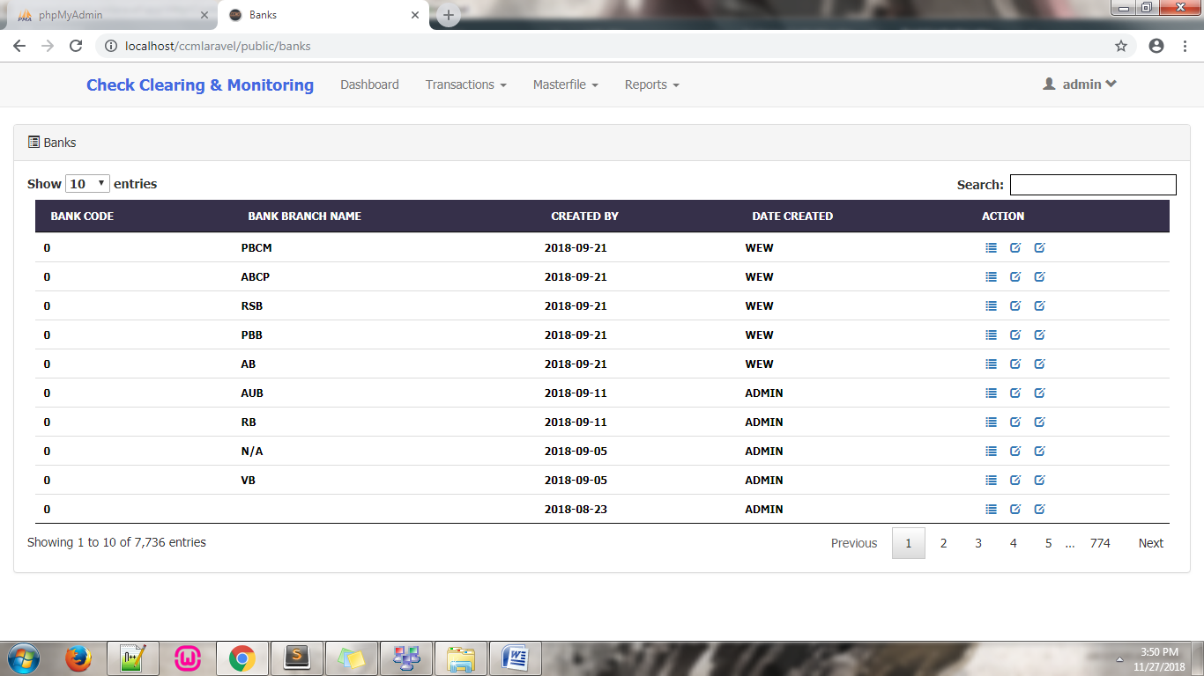

To:

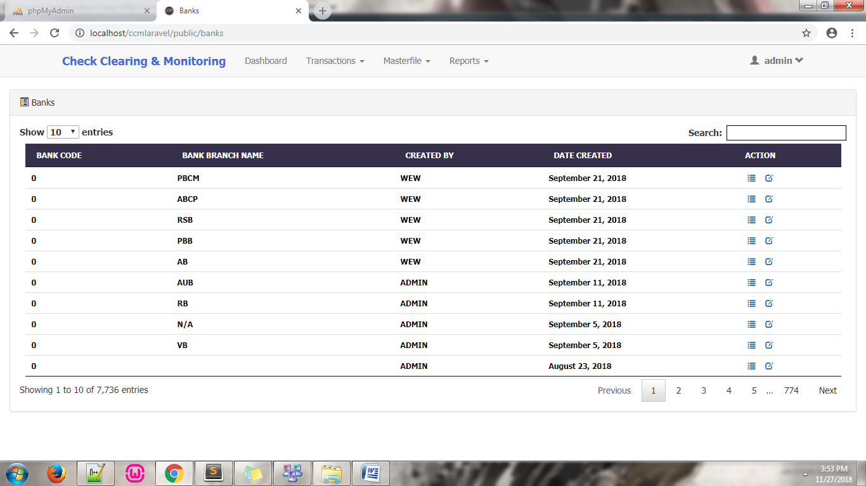

– added functionality for viewing and editing in the ACTION column.

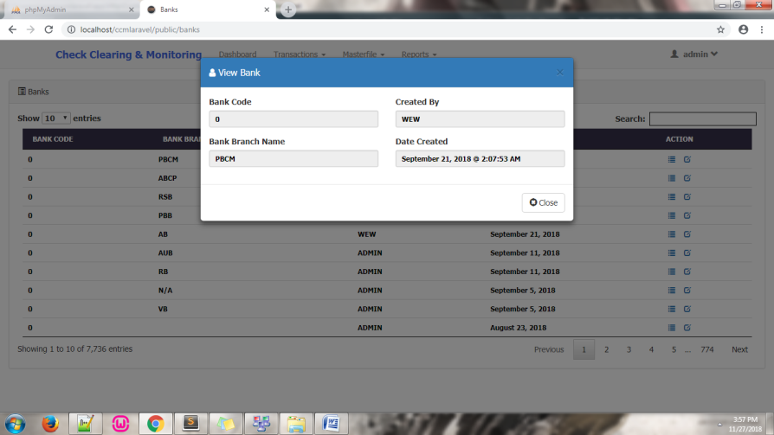

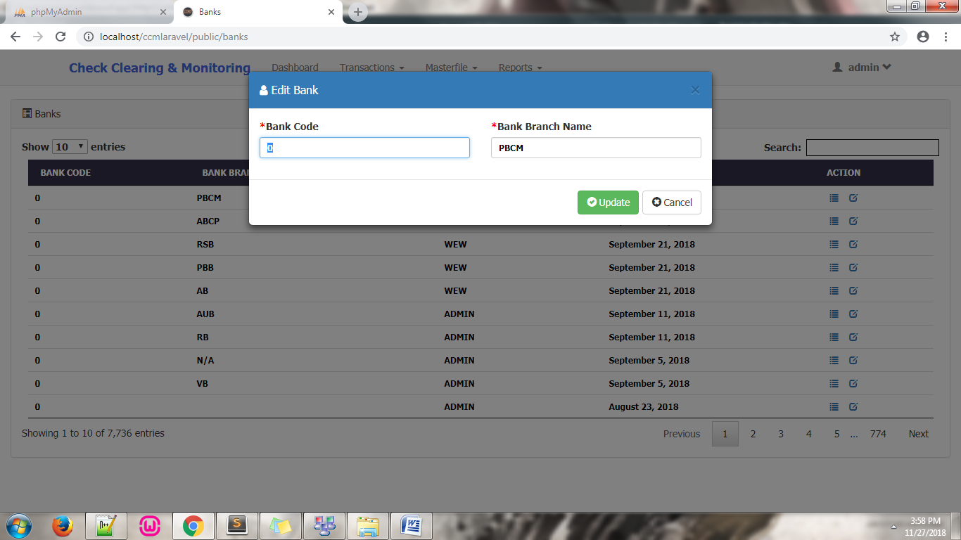

– Files modified:

* Date modification: app/Http/Controllers/**BankController.php** in ***function getAllBanks ()*** line **158**

Viewing functionality files modified:

* Js: public/js/**funct5.php** line **1633**
* Routes: routes/**web.php** line **91**
* Controllers: app/Http/Controllers/**BankController.php** in ***function viewbankdialog($id)*** line **177**
* View: resources/views/bank/**viewbank.blade.php**

Editing functionality files modified:

* Js: public/js/**funct5.php** line **1687**
* Routes: routes/**web.php** line **93**
* Controllers: app/Http/Controllers/**BankController.php** in ***function editbankdialog($id)*** line **185**
* View: resources/views/bank/**editbank.blade.php**
* **Masterfile – Check**

– modified the check list; CHECK DATE column has been modified, EDIT and CHANGE PASSWORD ACTION has been removed.

Modified from:

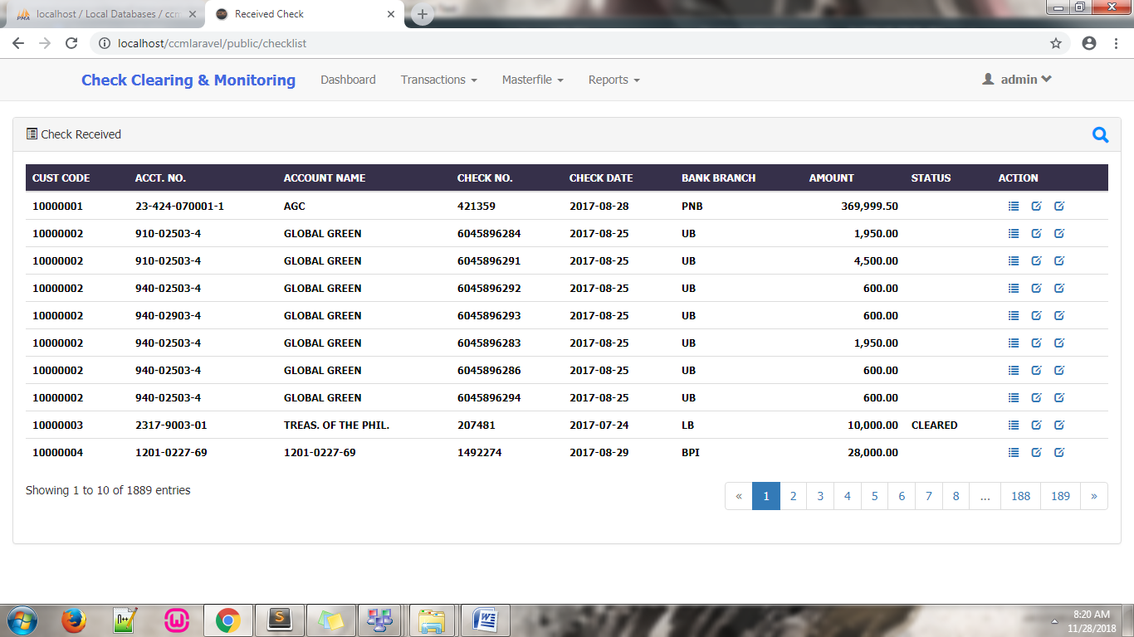

To:

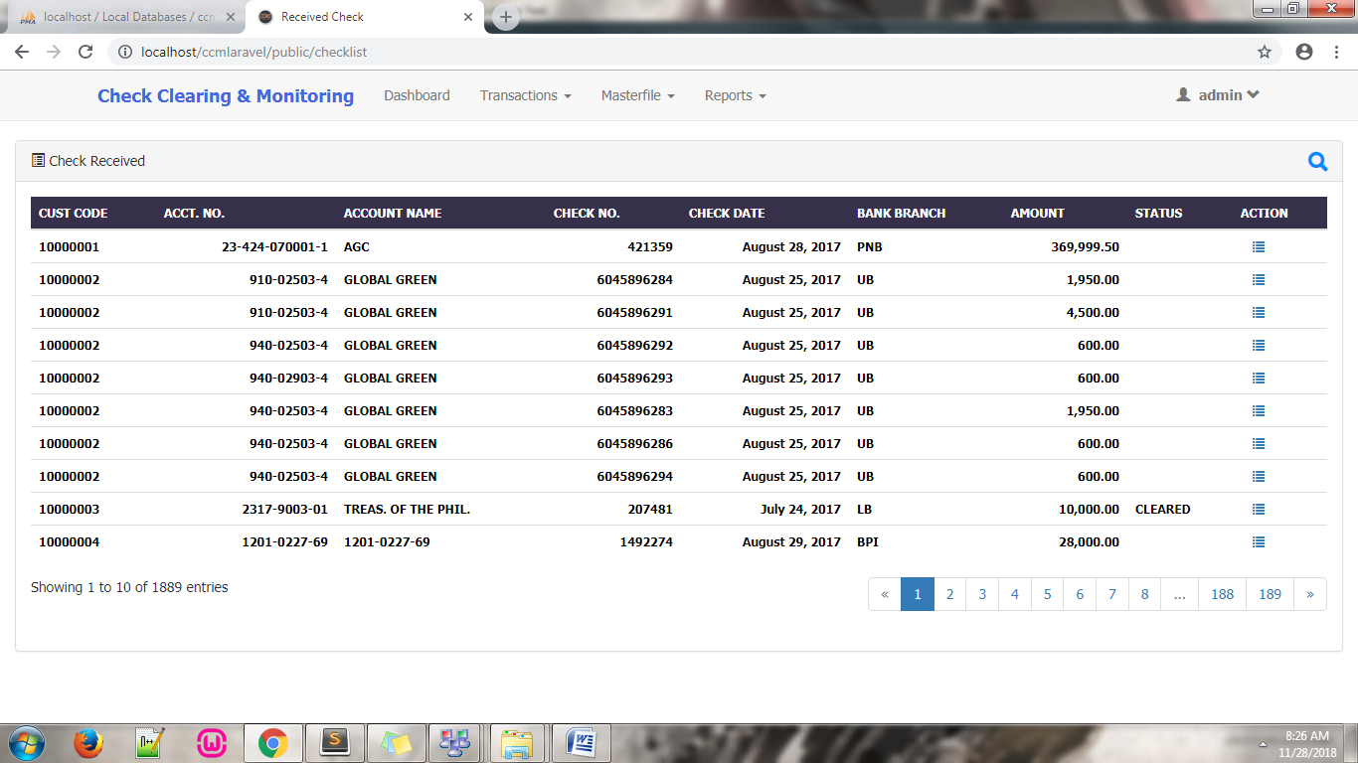

– added functionality for viewing in the ACTION column.

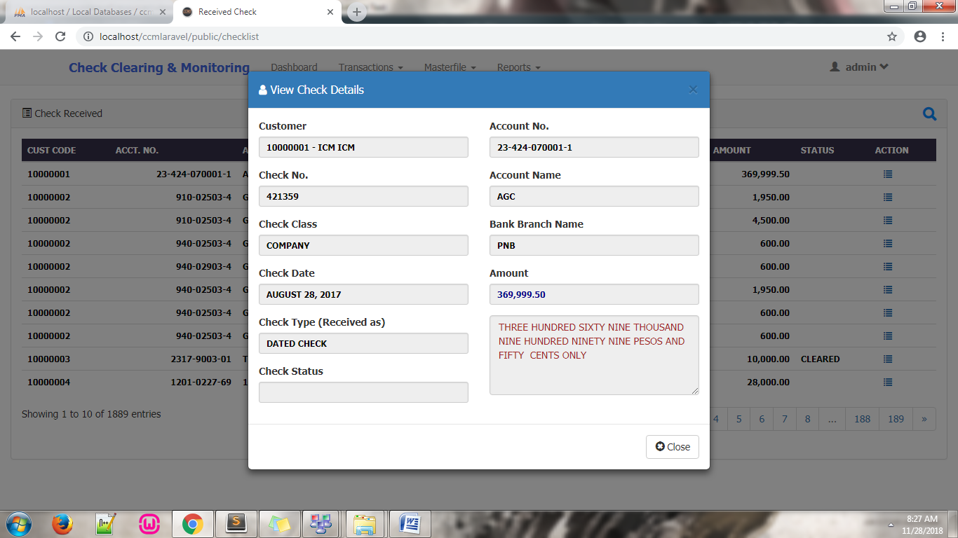

– Files modified:

* Date modification: resources/views/check/**loadchecks.blade.php** line **24**

Viewing functionality files modified:

* Js: public/js/**funct5.php** line **2899**
* Routes: routes/**web.php** line **136**
* Controllers: app/Http/Controllers/**CheckController.php** in ***function viewCheck($id)*** line **622**
* View: resources/views/check/**viewcheck.blade.php**
* **Reports – Checks for Deposit**

– modified the check list; CHECK DATE column has been modified, fixed Export Excel function not generating the same result with the result set in the view, and fixed Save not saving checks that are tagged as bounced.

Modified from:

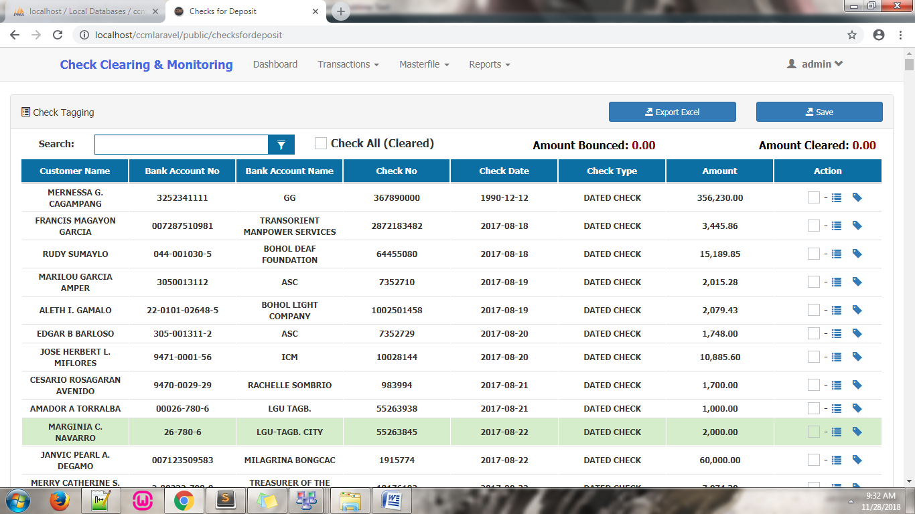

To:

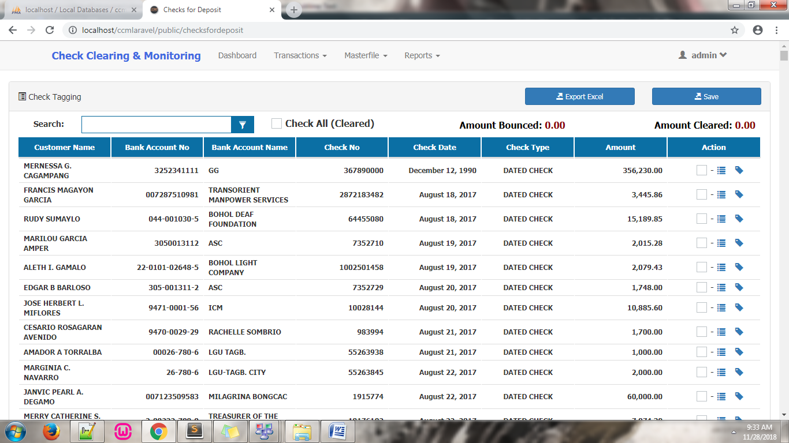

– Files modified:

* Date modification: resources/views/check/**checksfordeposit.blade.php** line **90**

Export Excel:

* View: resources/views/check/**checksfordeposit.blade.php** line **16**
* Js: public/js/**funct5.php** line **2766**
* Routes: routes/**web.php** line **174**
* Controllers: app/Http/Controllers/**CheckController.php** in ***function checksforDepositExport()*** line **2110**

**Sample Excel Output:**

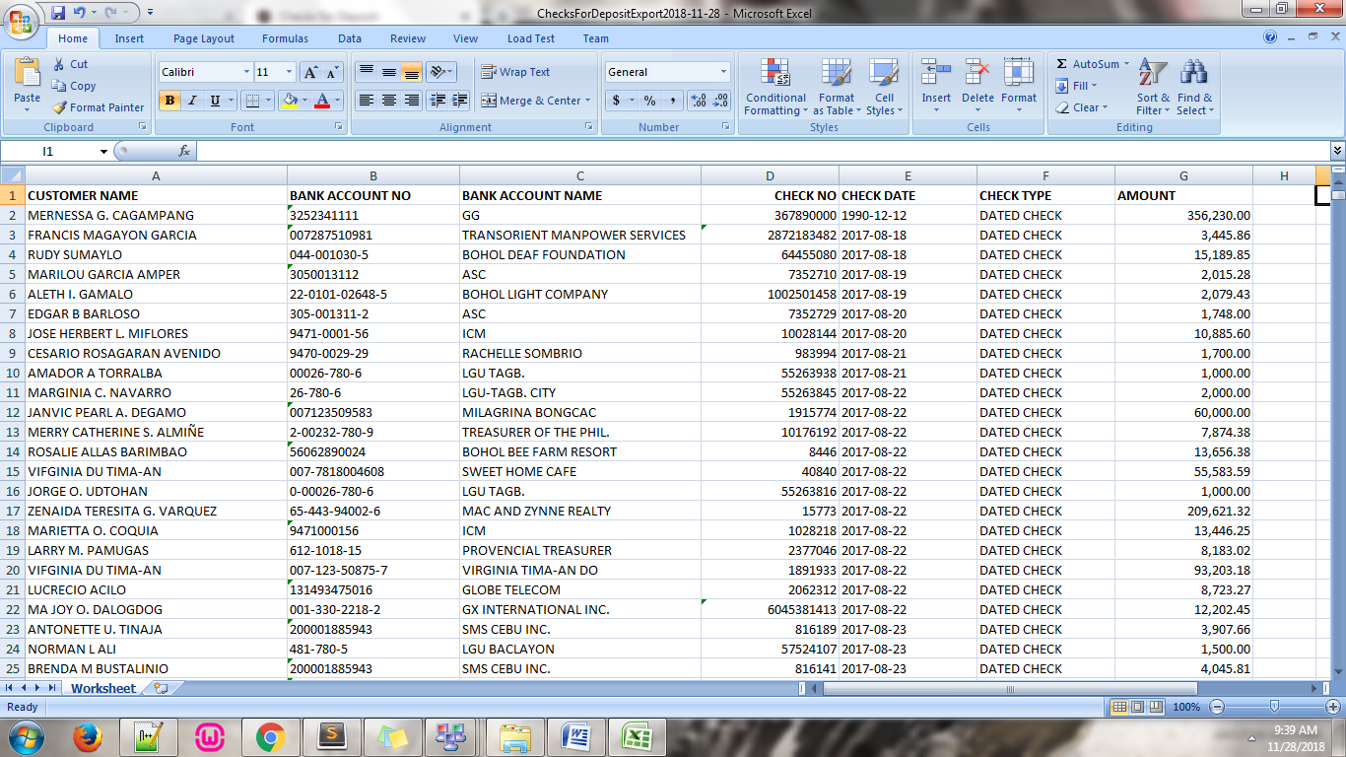

Save:

* View: resources/views/check/**checksfordeposit.blade.php** line **21**
* Js: public/js/**funct5.php** line **3696**
* Js: public/js/**funct5.php** line **4082**
* **Reports – Due Checks**

– modified the check list; CHECK DATE column has been modified, small circle/dot icon below the title of the list has been removed, Check All as Cleared checkbox and other checkboxes has been removed, Save button has been removed, and ACTION column has been removed.

Modified from:

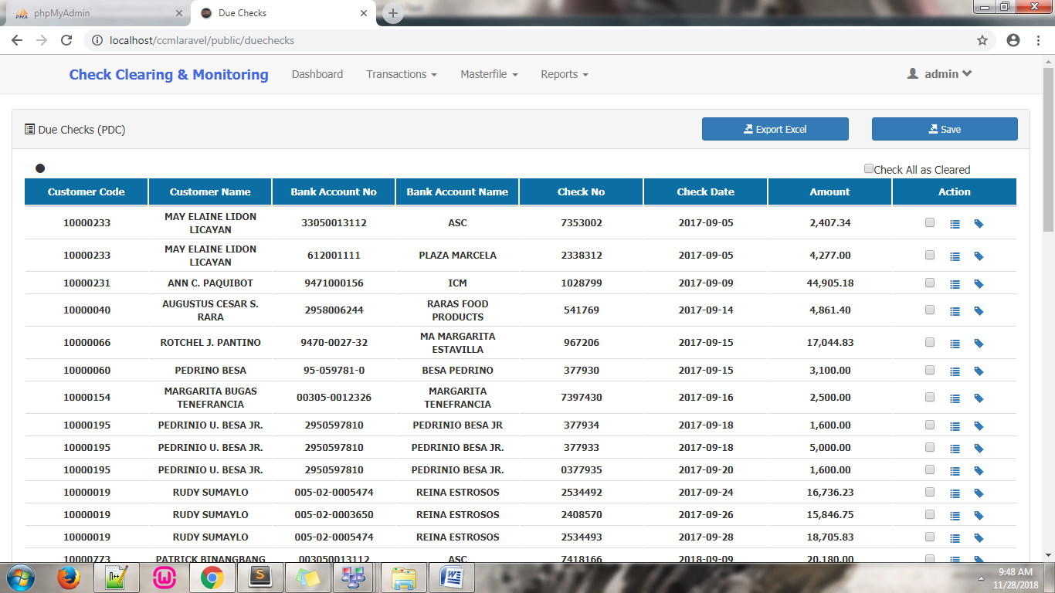

To:

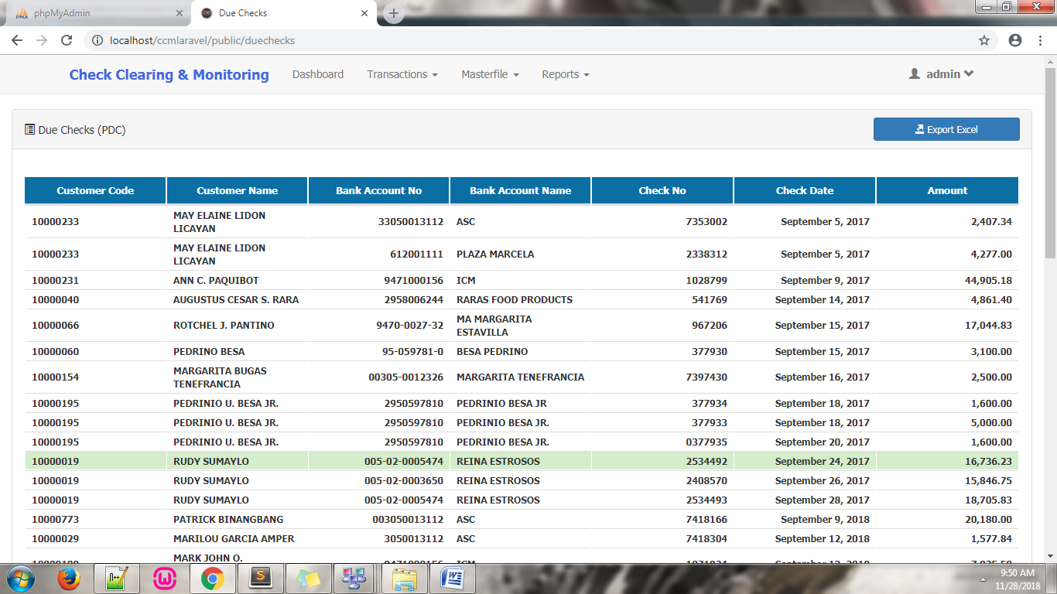

– Files modified:

* Date modification: resources/views/check/**duechecks.blade.php** line **56**

**Sample Excel Output:**

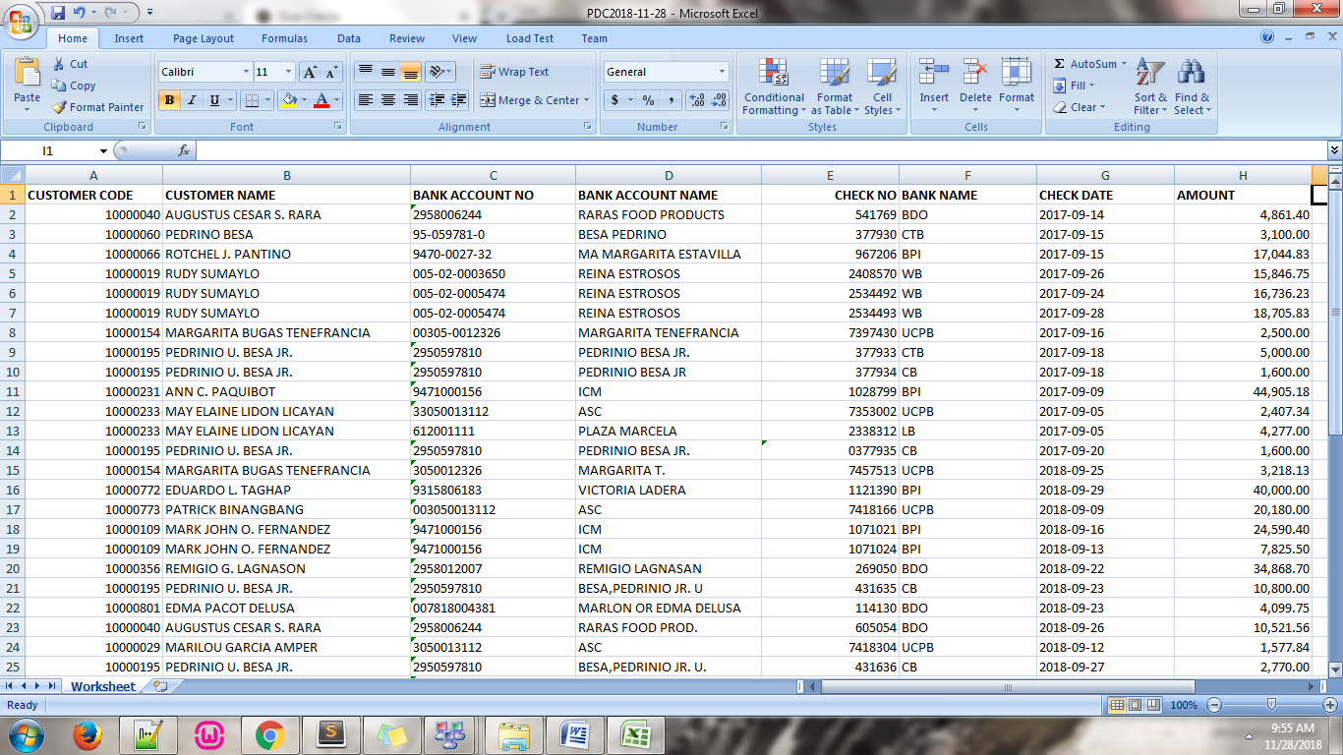

* **Reports – Checks for Clearing**

– modified the check list; CHECK DATE column has been modified, and Export Excel function has been fixed.

Modified from:

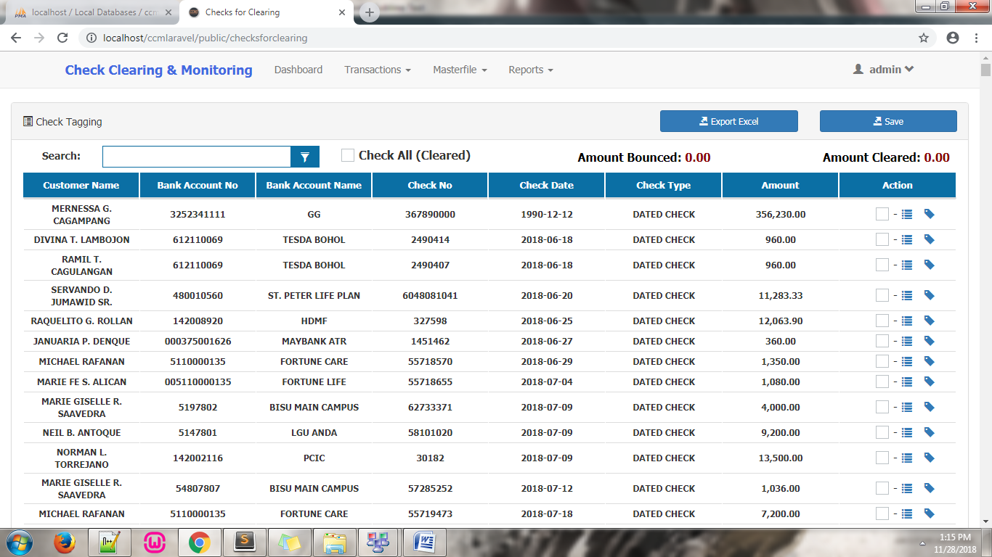

To:

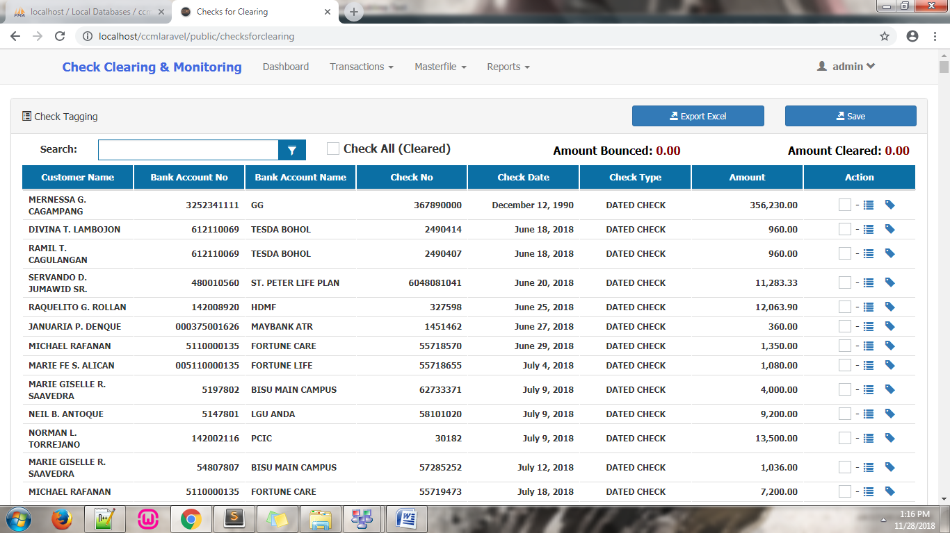

– Files modified:

* Date modification: resources/views/check/**checksforclearing.blade.php** line **90**

Export Excel:

* View: resources/views/check/**checksforclearing.blade.php** line **16**
* Js: public/js/**funct5.php** line **2774**
* Routes: routes/**web.php** line **172**
* Controllers: app/Http/Controllers/**CheckController.php** in ***function checksforClearingExport()*** line **2036**

**Sample Excel Output:**

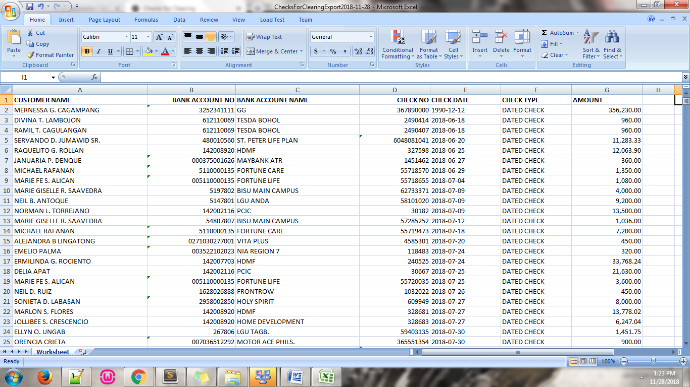

* **Reports – Cleared Checks (Batch)**

– modified the check list; CHECK DATE column has been modified, small circle/dot icon below the title of the list has been removed, Check All as Cleared checkbox and other checkboxes has been removed, Save button has been removed, ACTION column has been removed, and Export Excel function has been fixed.

Modified from:

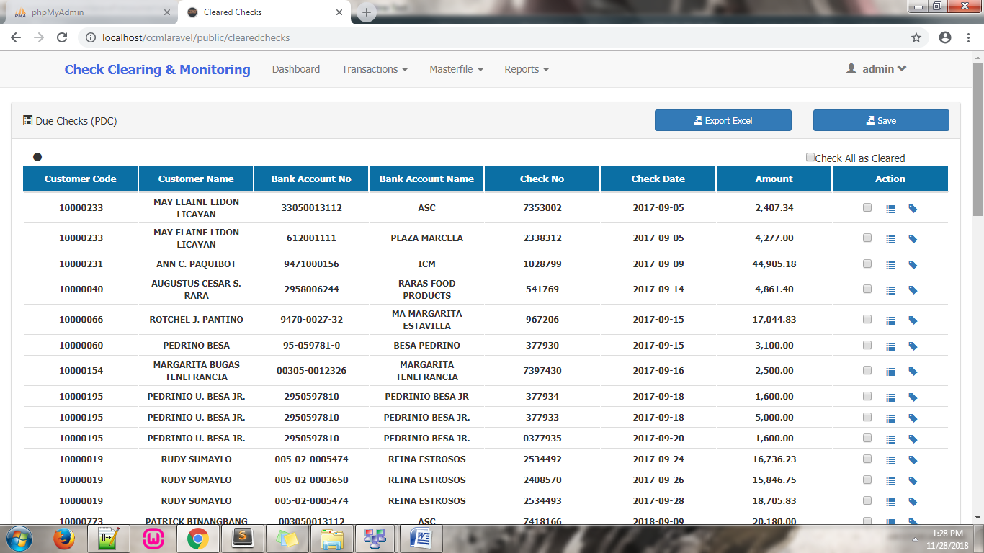

To:

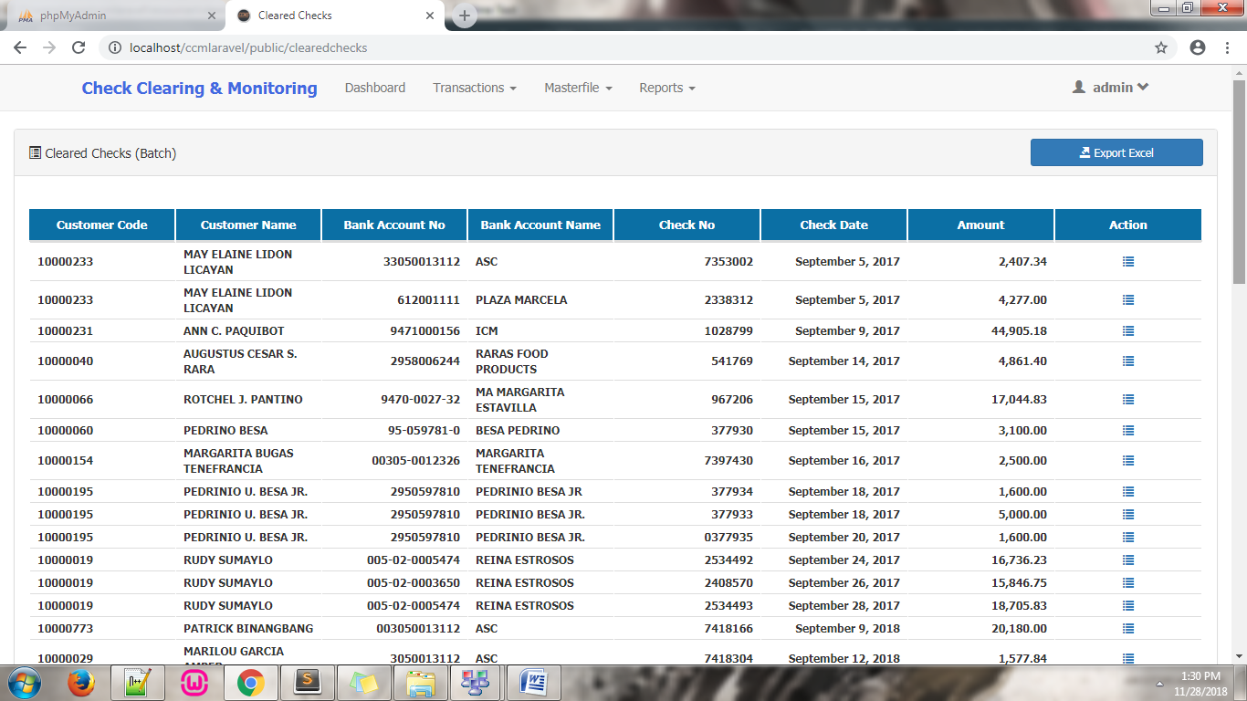

– Files modified:

* Date modification: resources/views/check/**clearedchecks.blade.php** line **60**

Export Excel:

* View: resources/views/check/ **clearedchecks.blade.php** line **25**
* Js: public/js/**funct5.php** line **2766**
* Routes: routes/**web.php** line **170**
* Controllers: app/Http/Controllers/**CheckController.php** in ***function duePdcExport()*** line **1844**

**Sample Excel Output:**

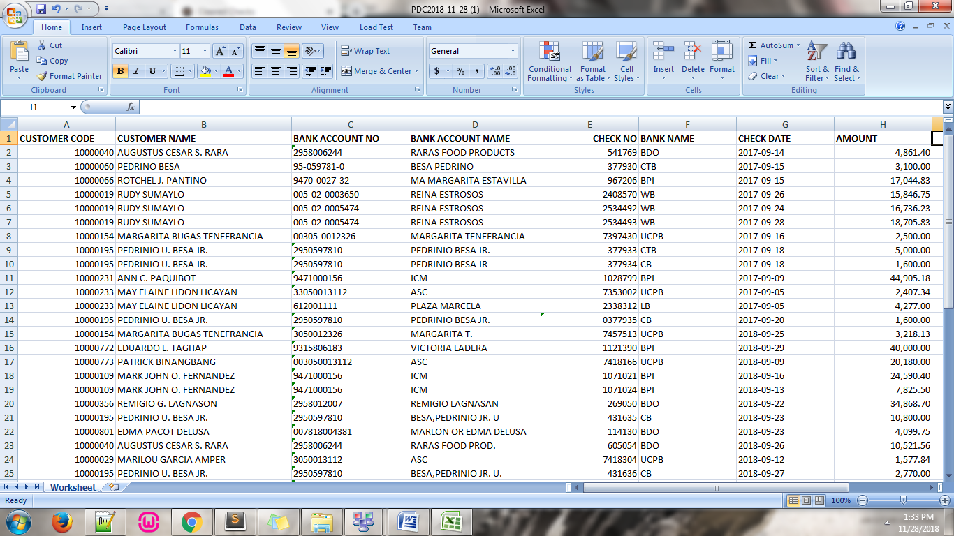

* **Reports – Due Checks**

– added Search functionality and pagination for table.

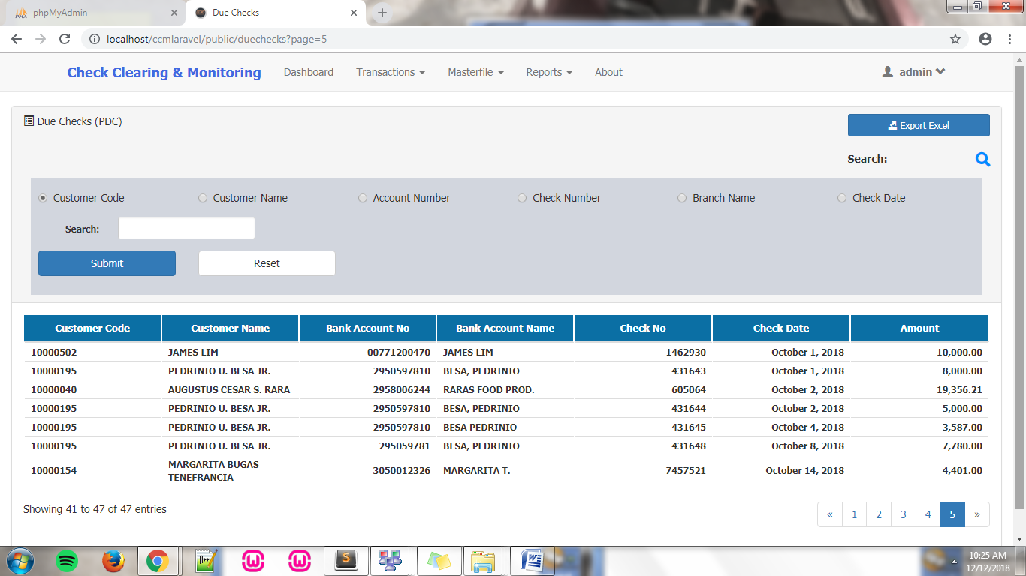

– Files modified

Search Function and Pagination:

* View: resources/views/check/**loadduechecks.blade.php**
* View: resources/views/check/**checklistduechecks.blade.php** line **81**
* Routes: routes/**web.php** line **154**
* Controllers: app/Http/Controllers/**CheckController.php** in ***function dueChecks()*** line **1199**
* **Reports – Cleared Checks (Batch)**

– added Search functionality and pagination for table.

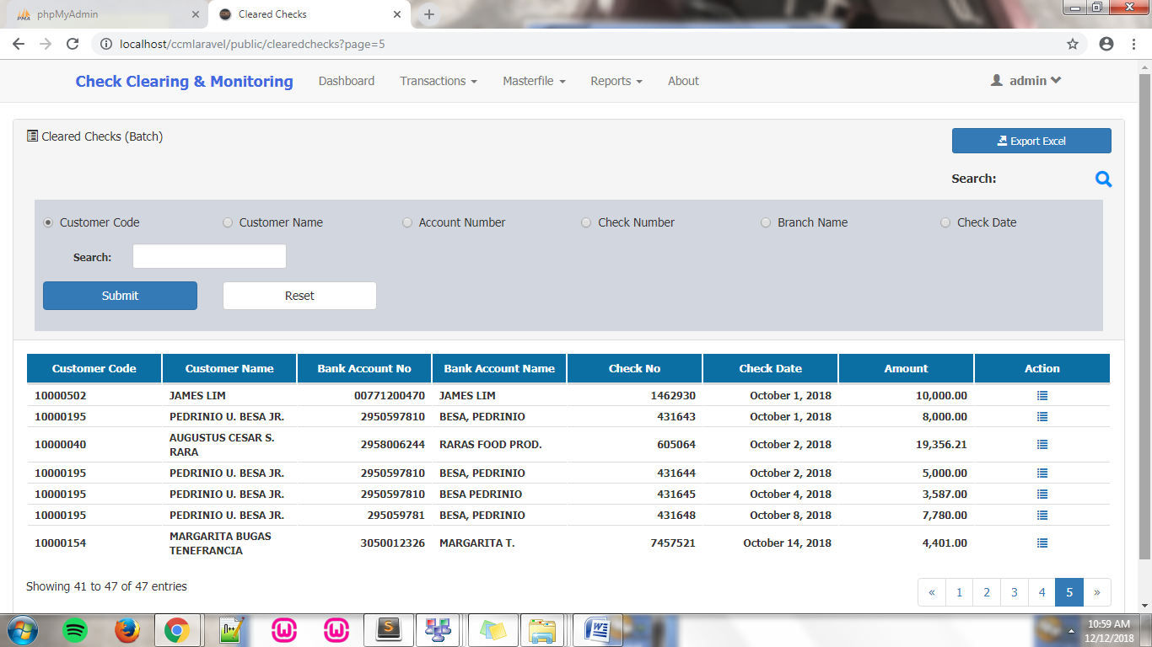

– Files modified

Search Function and Pagination:

* View: resources/views/check/**loadclearedchecks.blade.php**
* View: resources/views/check/**checklistclearedchecks.blade.php** line **81**
* Routes: routes/**web.php** line **156**
* Controllers: app/Http/Controllers/**CheckController.php** in ***function clearedChecks()*** line **1256**
* **Reports – Bounced Check**

– added saving functionality for multiple clearing of bounced checks.

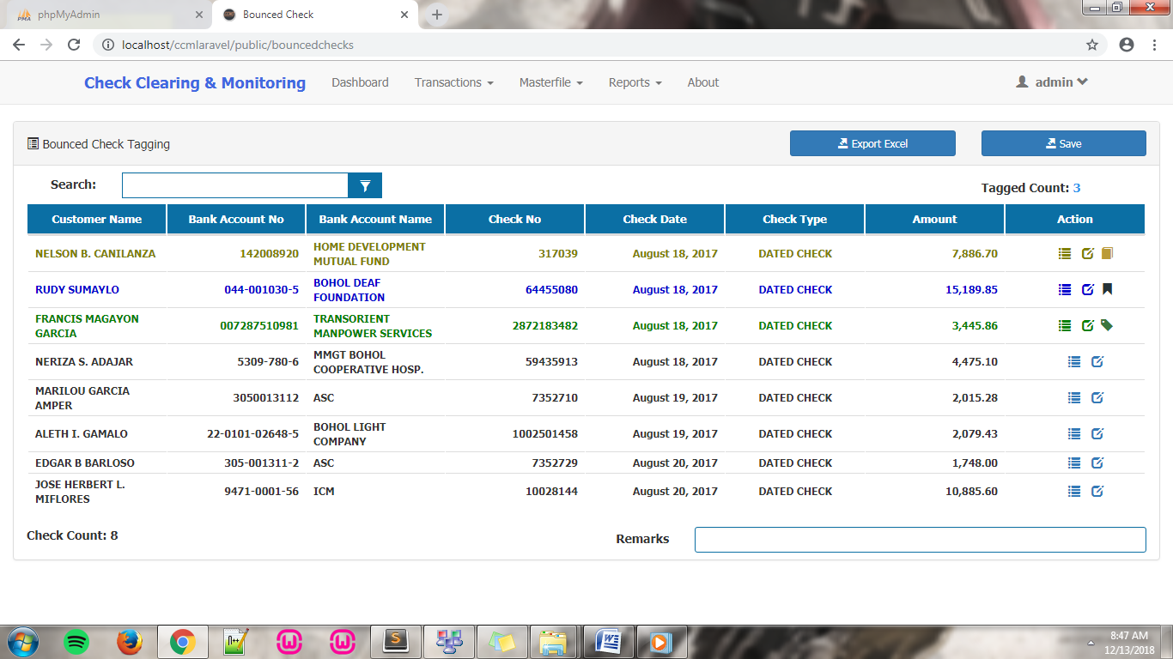

– Files modified

Update bounced checks:

* Js: public/js/**funct5.php** line **3022**
* View: resources/views/check/**bouncedcheck.blade.php**
* View: resources/views/check/**updatebouncedcheck.blade.php**
* View: resources/views/check/**viewcheckupdateCash.blade.php**
* View: resources/views/check/**viewcheckupdateRedeposit.blade.php**
* View: resources/views/check/**viewcheckupdateReplacement.blade.php**
* Routes: routes/**web.php** line **160**
* Routes: routes/**web.php** line **164**
* Routes: routes/**web.php** line **168**
* Controllers: app/Http/Controllers/**CheckController.php** in ***function BouncedChecks()*** line **1370**
* Controllers: app/Http/Controllers/**CheckController.php** in ***function UpdateBouncedChecks()*** line **1432**
* Controllers: app/Http/Controllers/**CheckController.php** in ***function UpdateBouncedChecksTemp()*** line **1484**
* Controllers: app/Http/Controllers/**CheckController.php** in ***function addToBounceCart()*** line **1863**
* Controllers: app/Http/Controllers/**CheckController.php** in ***function addToBounceCart2()*** line **1889**
* Controllers: app/Http/Controllers/**CheckController.php** line **12**
* Class: app/**BounceCart.php** in ***function update2()*** line **67**
* Class: app/**BounceHistory.php**

Save bounced checks:

* Js: public/js/**funct5.php** line **3886**
* Js: public/js/**funct5.php** line **4081**
* Routes: routes/**web.php** line **108**
* Controllers: app/Http/Controllers/**CheckController.php** in ***function savebouncedcheck()*** line **2353**
* **Added About page**

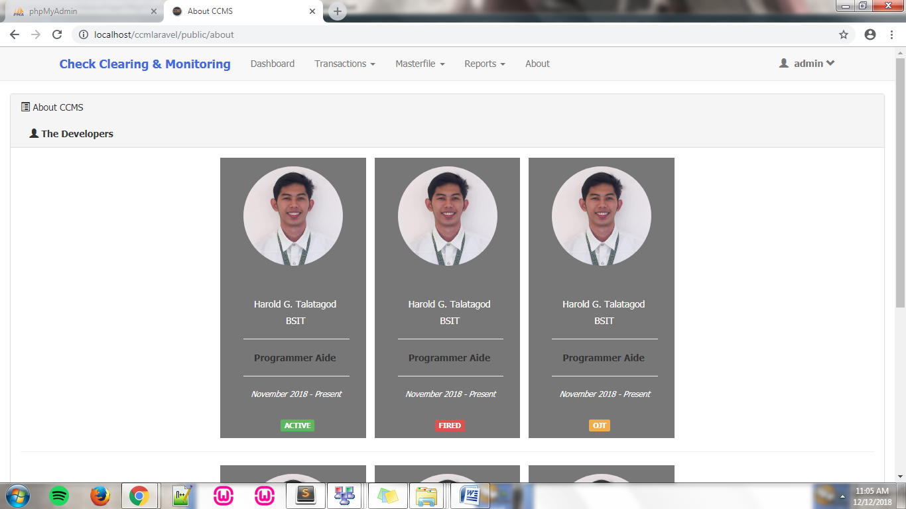

– Files Added

About Page:

* View: resources/views/**about.blade.php**
* Routes: routes/**web.php** line **22**
* Controllers: app/Http/Controllers/**HomeController.php** in ***function about()*** line **48**

**General modifications and Changes**

* Modified most dates; i.e. from 11/20/2018 to November 20, 2018
* Polished some table column, left aligned and right aligned
* Polished not functional buttons; i.e. Save, and Export Excel
* Added Viewing, and Editing functionalities for most master list

**Minor modifications and Changes**

* Proper labeling of input fields
* Proper labeling of icons
* Removed unwanted icons and buttons